How to completely Uninstall Docker from Ubuntu Flavour

Step 1 : run the below command which will display what are the docker packages are there in the system.

We have two package called “docker-ce” & “docker-ce-cli”



Step 2: Please run the below commands to completely remove the docker packages from the system.

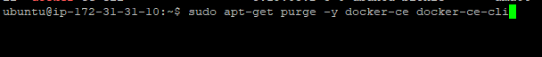



The above commands will not remove images, containers, volumes, or user created configuration files on your host. If you wish to delete all images, containers, and volumes run the following commands

Step 3:



Step 4: Remember we added our userid “Ubuntu” in the docker group. We have to delete that docker group as well.



Step 5:



That’s all, You can check whether docker is removed or not ??

Step 6 :

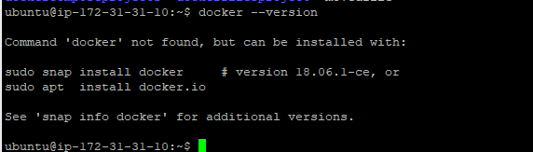

Yes – It’s removed.